**Part 2:**

The significance of data transfer and the motivation behind the initiative is to make ure secure and fast delivery of data in modern communication networks. The rapid increase in complexity and size of data flow because of technologies like edge computing, IoT, and 5G networks have raised challenges in data transmission. Present systems like the internet, wired and wireless networks, protocols, and algorithms have drawbacks in handling rising data transfer demands, maintaining data security, and efficiently transporting large amounts of data. Category drawbacks and security issues also make data distribution tough.

To control these challenges, a novel two-router model has been introduced that takes into account category drawbacks and network data transfer threats. The approach used includes developing scheduling algorithms that dynamically allocate resources and give priority to data transfer operations while considering category constraints, network conditions, and security requirements. The data transfer method utilizes strong authentication and encryption to make sure data security and integrity. Simulations are conducted to compare the results with other approaches and systems that are in use.  
  
There are two routers included in the existing layout. One router is responsible for managing the network that serves as the origin, while another router is in charge of managing the network that serves as the destination. Thanks to scheduler technologies, routers can efficiently divide resources and prioritise tasks related to data transmission. The connection between them is safe and uninterrupted. One of the components that make up the notion is a category translator. Thanks to this translator, data can be efficiently transferred across various categories. At this stage, the plan includes visual representations of the specific architectural features.

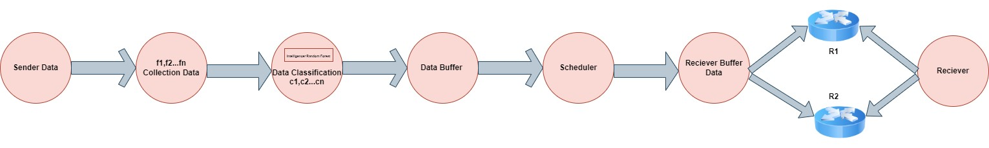

Using two routers, the technology effectively bypasses the limitations of data transportation. These problems arise due to certain restrictions and security concerns. A secure connection will be established between the two routers as part of the setup. Furthermore, to streamline the data transfer process across multiple categories, a category translator can be used. By utilising efficient scheduling algorithms and reliable data transfer technology, the objective can be achieved. As a result, this guarantees that the data transfer is both efficient and secure.